BIOC 455
Lecture #3 – Introduction to the CNS
Lecturer: Dr. Cermakian – January 10th, 2007

NOTE: This NTC is meant to be used as a study aid to supplement your own class notes. Hence, not all of the text or diagrams contained in the lecture slides will be reproduced here.

Please send any comments or questions about NTCs to either Wanda or James through e-mail at u3.represent@gmail.com .

Brain energy metabolism continued

Brief Glycolysis and Creb cycle review
Glucose is converted to glucose-6-P which is converted to pyruvate to produce 2 ATP. NADH and ATP can inhibit the glycolysis pathway. Pyruvate can be reversibly converted to lactate or transformed to Acetyl coA and go to the citric acid cycle to make 36 ATP.

Glucose is the main energy substrate for the brain and constitutes 25% of total body glucose utilization. It comes from two sources: first from circulating plasma glucose and secondly from glycogen stores. Almost only oxidized glucose from glycolysis and the citric acid cycle are used to make a combined 38 ATP/glucose (more than 85%). Less than 15% of the energy used to incorporate metabolic intermediates, lipids, proteins, glycogen, and neurotransmitters.

The brain consumes 20% of total oxygen used by the organism and this is up to 50% in children.When we are younger, we use more oxygen and during REM sleep, when we dream.

Other substrates for brain energy metabolism
Ketone bodies (starvation, diabetes, breast-fed neonates)
In theory there is also:
- Mannose (crosses BBB but normally not present in the blood).
- Lactate and pyruvate (barely cross BBB; have to be produced on site through glycolysis).

Previously, the topic of BBB was introduced. At the blood brain barrier you can find what is called the end feet of astrocyte (also astrocyte foot process). These end-feet surround the capillaries and wrap around synapses. There is a 10: 1 astrocyte to neuron ratio in the brain. The rate of glucose utilization and amount is a lot more by astrocyte.

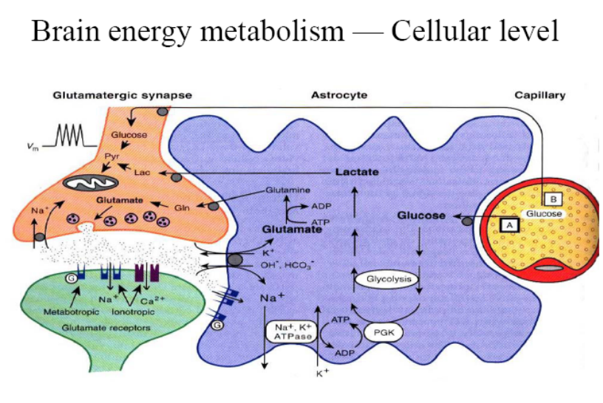
In this diagram there are 2 neurons: one presynaptic and one postsynaptic forming a synapse. When you have neuronal activation: the neuron takes glucose and transforms it into glumatamate (neuron activator) to be released from the presynaptic cell to activate receptor of postsynaptic neuron and transmit signal.
Neuronal activation requires a lot of energy therefore it needs the help of astrocyte to have metabolism control. To help drive the metabolism, there is active transport of glutamate since a lot in synaptic cleft and not all is needed. Therefore you add glutamate in cell and this works as a symporter with a sodium potassium pump (Na goes out/ K+ goes in) on the astrocyte next to synapse. This process requires ATP. When this pump functions, glycolysis will increase since ATP levels will go down and more glucose will be uptaken from blood vessels at BBB. Glutamate that was uptaken by the astrocyte can be converted to glutamine and sent back to presynaptic neuron to make glutamate again.

Energy consuming processes in the brain:
- active transport of ions across membranes (about 50%)
- synthesis of molecules used for communication and general purposes
- axonal transport uses microtubule as track and molecular motors dynein and kinesin use ATP to transport cargo

Glucose cannot go through BBB; it needs glucose transporters to have a brain cellular distribution. You have 7 classes of glucose transporters which vary per type of cell.

Regional level
Structural and functional specialization in the brain
- localized energy requirement, glucose utilization and blood flow
- local increase in blood flow mediated by innervations of microvessels
When you have an energy requirement, you need glucose therefore you need more blood flow to a specific region. There is a link between energy requirement and blood flow (vasoconstriction of selectively used region)

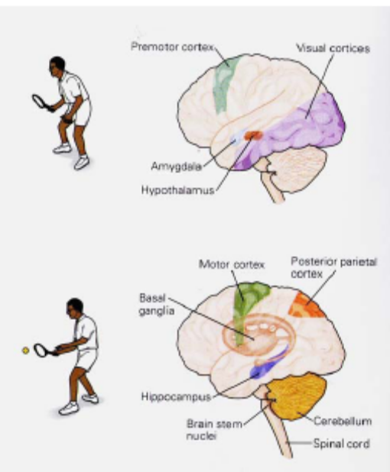
When you see the ball coming you need energy to different brain region as when you are about to hit the ball. The promoter cortex is activated for expectation in case you need to move and visual cortices to have a focus on ball. The amygdala is activated to control the motion. When you hit the ball, the hippocampus which is the center for memory lights up in order to refer to previous experience (how to move). Cerebellum and motor cortex light up to control movement. In summary, different regions in the brain can be used and activation for different functions and purposes. These specific regions will be the ones receiving energy and oxygen.

How to visualize glucose utilization in a rodent brain?
- Use of radioactive 2-deoxyglucose (2-DG) : this is a non metabolisable form of glucose molecule.
- It can be phosphorylated by hexokinase but cannot be used to make energy.
- It will be taken up by the brain through BBB.
- In the lab, you inject this in rodent and make it do a specific task which will require an increased uptake of glucose which will stay there and will not be metabolized.
- Then, section brain of the rodent and measure radioactive and concentration will indicate what regions of the brain are necessary for particular task.
- Accumulation of 2-DG will be in more active brain regions.
- Resolution of 50-100 micrometer.

Positron emission tomography (PET)
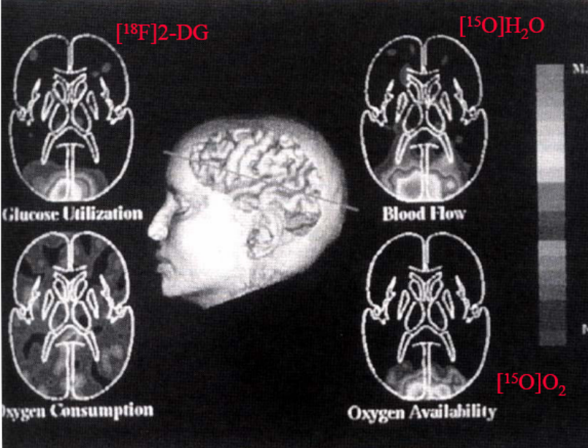

Human goes into a scanner and is asked to watch some images. Subject injected with F¹⁸ 2-DG usually directly into blood circulation to measure glucose utilization. This uses characteristics of decay of productive substances. Protrons (positive charges) decays into neutrons and positrons. Radioactive Fluor decays and positrons travel in tissue and will meet electrons and this meeting will produce 2 photons that will go in opposite direction. This phenomenon is what will be detected by the machine. Resolution of this technique is 5 mm. You could also used O¹⁵ H2O to measure blood flow in the brain. ¹⁸F DOPA is used to measure DA synthesis for example in Parkinsons disease. ¹¹C nomifensive for DA uptake and ¹¹C N-methyl-piperidylbenzilate to locate Ach receptors.

Functional magnetic resonance imaging (fMRI)
- Non invasive (meaning you don’t need to inject anything at all such as radioactive label).
- MR signal in relation to oxygenation (oxyhemoglobin gives diamagnetic signal and deoxyhemoglobin gives a paramagnetic signal). The ratio gives a measure oxygen consumption and blood flow.
- This technique is not as versatile as PET
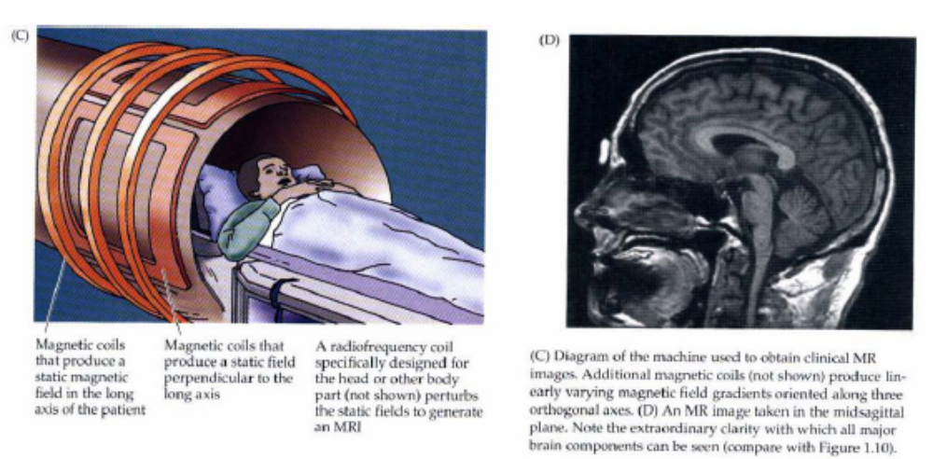
References for this section of course can be found in chapter 14 of Fundamental neuroscience
And chapter 19 in Principle of neural sciences chapter

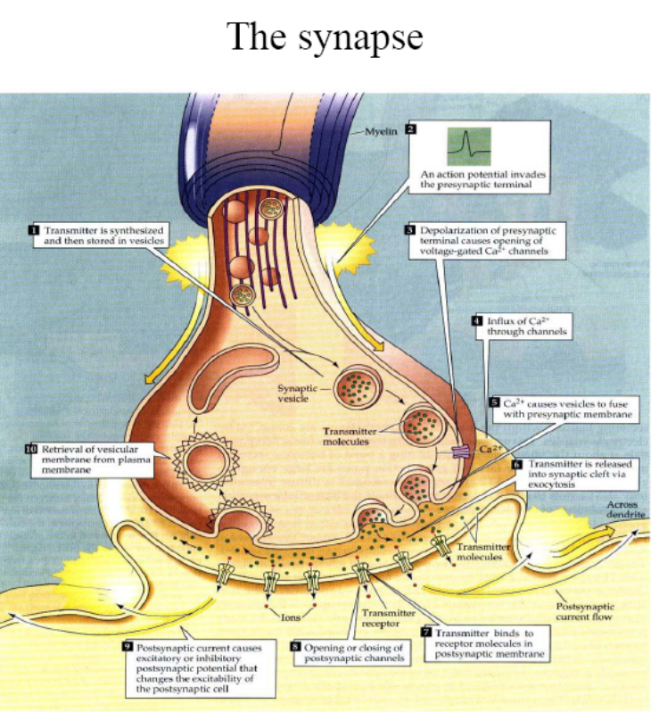

This is very important for neuron-neuron communication.

Summary of next four lectures

Categories of neurotransmitters (send message to other neurons)
Classical neurotransmitters, neuropeptides,…

Categories of neurotransmitter receptors
Metabotropic receptors, ionotropic receptors, receptor protein tyrosine kinases, neuropeptide receptors

Methods to study neurotransmitter receptors

Categories of neurotransmitters

Classical neurotransmitter: glutamate, serotonin
Neuropeptides: vasopressin, neuropeptide Y
Gaseous molecules: nitric oxide
Growth factors: nerve growth factor
Other molecules: glucocorticoids

Classical neurotransmitter

Majority of neurotransmitter will express glutamate (main excitatory) or GABA (main inhibitor).

4 types of Receptors

Channel-linked receptor: also called ionotropic receptor since it is in fact an ion channel. It is a transmembrane protein. Ligand binds and leads to opening in channel that will selectively let ion pass through. Example: Glutamate binds ion channel and Calcium will go through channel which will affect function of cell.

G protein coupled receptors: they are not channel; they are mediators. They activate a pathway in the cell. Upon ligand binding, signalling pathway will be activated.

Enzyme-linked Receptor that are themselves enzyme, especially protein tyrosine kinase receptors. Upon ligand binding, growth factor for example activity of receptor will start and phosphorylation of receptor for example will initiate downstream pathway.

Intracellular receptor: they are not membrane protein. They are inside the membrane for example glucocorticoid receptor. Ligand is lipid soluble move through membrane. When it binds the glucocorticoid receptor-ligand complex can move to nucleus where it will act on transcription. It will be a transcription factor.

The range in activation time varies per receptor type. Channel-linked receptors work within milliseconds but will not last for a long time. GPCR can be slow to start but works longer.
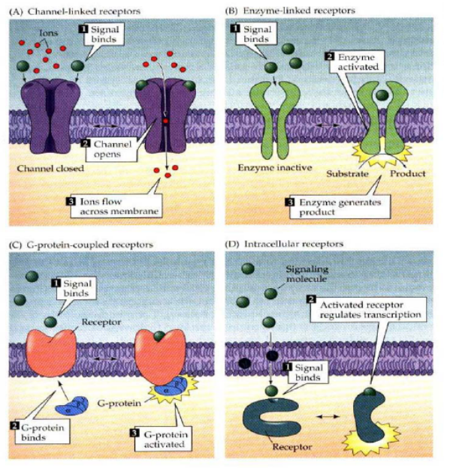
G protein couple receptors (GPCRs)
- Hundreds of GPCRs
- 60% of clinically relevant drugs (important in pharmacology and neurobiology since most drug target this type of receptor)
- 7 transmembrane protein, N terminus extracellular, C terminus intracellular
- domains are quite concerved but the extra and intra cellular loops provides divergence which gives functions or interaction specificity.
- Important in brain function
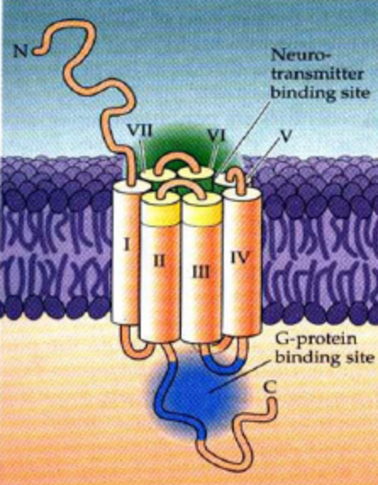
Examples of GPCR classes: Glutamate, GABA, Dopamine, NE, Epi, Serotonin, Histamine, Purines, Muscarinic and many more neuropeptides.

www.wikepedia.org

